**PROJECT HUMAN RESOURCES MANAGEMENT**

1. Introduction

1.1 Issues involving problems in human resources

2. Human Resource Plan

2.1 Description

2.2 Project Matrix Organization Chart

2.3 Project Team Roles and Responsibilities

2.4 RACI Chart

2.5 Resource Histogram

2.6 Motivational Theory

3. Acquire Project Team

3.1 Description

3.2 Negotiation

3.3 Acquisition

4. Develop Project Team

4.1 Description

4.2 Tuckman Model

4.3 Training

4.3.1 Training Plan

4.3.2 Training Evaluation Sample Template

4.4 Teambuilding activities

4.5 Ground Rules

4.6 Co-location

4.7 Recognition and Rewards

4.8 The Myers-Briggs Type Indicator (MBTI)

5. Manage Project Team

5.1 Observation and Conversation

5.2 Performance Appraisal

5.2.1 Performance Evaluation Form

5.3 Managing Conflict

5.4 Skills to Manage Project Team

6. Conclusion

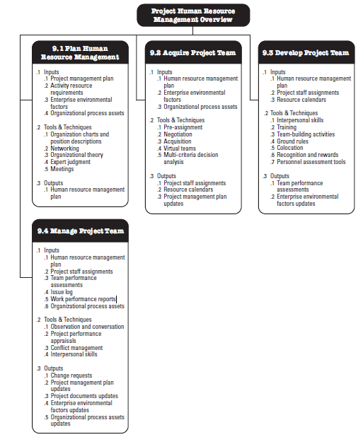

**PROJECT RISK MANAGEMENT**

1. Introduction

1.1 Issues involving problems in risk

2. Project Risk Management Process

3. Risk Planning

3.1 Roles and Responsibilities

4. Risk Identification

5. Qualitative Risk Analysis

5.1 Probability Impact Matrix

6. Quantitative Risk Analysis

7. Risk Respond Planning

7.1 Positive Risk Response

7.2 Negative Risk Responds

7.3 Risk Register

8. Risk Monitoring and Control

9. Conclusion

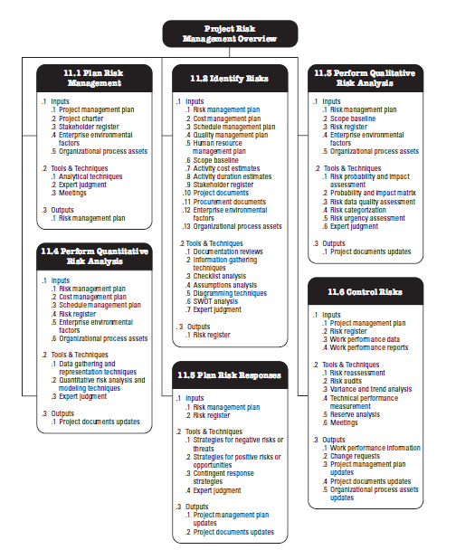

**PROJECT COMMUNICATION MANAGEMENT**

1. Introduction

1.1 Issues involving problems in communication

2. Plan Communication Management

2.1 Communication Requirements Analysis

2.2 Communication Roles and Responsibilities

2.3 Communication Management Plan Template

2.4 Communication Technology

2.5 Communication Models

2.6 Communication Method

2.7 Communication Matrix

3. Manage Communication

3.1 Performance Reporting

3.2 Status Report

3.3 Progress Report

3.4 Forecast Report

4. Control Communication

4.1 Issue Log

4.2 Sample Issue Log

5. Conclusion

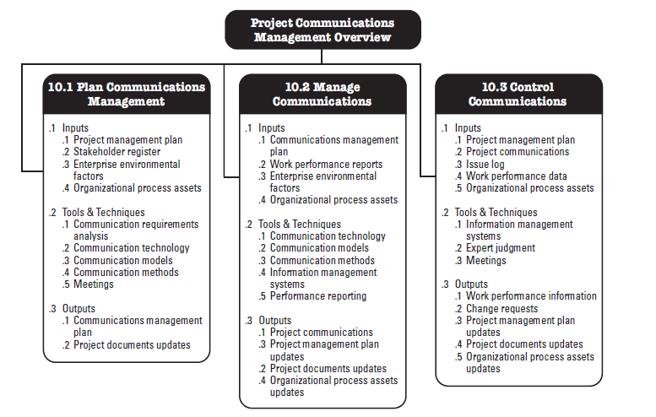

**PROJECT PROCUREMENT MANAGEMENT**

1. Introduction to Procurement

1.1 Issues involving problems in procurement

2. Plan Procurement Management

2.1 Make or Buy Analysis

2.2 Procurement Team

* Roles and Responsibilities

2.3 Procurement Statement of Work

2.4 Procurement Documents

* Request for Quote
* Request for Information
* Request for Proposal

2.5 Source Selection Criteria

3. Conduct Procurement

3.1 Seller Proposal

3.2 Bidder Conference

3.3 Proposal Evaluation Technique

3.4 Advertising

3.5 Tender Evaluation

3.6 Negotiation

3.7 Selecting Sellers

3.8 Agreements

4. Control Procurement

4.1 Change Request

4.2 Performance Review

4.3 Inspection and Audits

4.4 Performance Report

4.5 Payments

4.6 Claims Administration

4.7 Records and Documentation Management

5. Close Procurement

5.1 Procurement Audit

5.2 Procurement Negotiations

5.3 Deliverable Acceptance

6. Conclusion

